**Project Based Learning-II**

(Guidelines and Work Book)

**Course Code: 210258**

**(2019 Course)**

**Second Year Engineering**

Year 2020 - 2021

Group ID: **2**

Team Members:

1. **Mayur Mhatre (SACO19130)**
2. **Shruti Lade (SACO19132)**
3. **Khushboo Patil (SACO19133)**
4. **Gaurav Ghyar (SACO19141)**

Project Title: **IOT BASED DUST CONCENTRATION MONITORING SYSTEM**

Name of Mentor: **Dr. Manisha Bhende**

**A PRELIMINARY REPORT ON**

**IOT BASED DUST CONCENTRATION MONITORING SYSTEM** **USING DUST, AIR, TEMPERATURES SENSOR AND CLOUD MANAGEMENT USING SERVER**

SUBMITTED TO THE SAVITRIBAI PHULE PUNE UNIVERSITY, PUNE

IN THE PARTIAL FULFILLMENT OF THE REQUIREMENTS

FOR THE ACADEMIC

OF

**SECOND YEAR OF COMPUTER ENGINEERING**

**SUBMITTED BY**

**MAYUR MHATRE ROLL NO. SACO19130**

**SHRUTI LADE ROLL NO. SACO19132**

**KHUSHBOO PATIL ROLL NO. SACO19133**

**GAURAV GHYAR ROLL NO. SACO19141**



## DEPARTMENT OF COMPUTER ENGINEERING

## DR. D.Y. PATIL INSTITUTE OF ENGINEERING, MANAGEMENT & RESEARCH, AKURDI, PUNE 411044

**SAVITRIBAI PHULE PUNE UNIVERSITY**

2020 -2021



**CERTIFICATE**

This is to certify that the project report entitles

**“IOT BASED DUST CONCENTRATION MONITORING SYSTEM** **USING DUST, AIR, TEMPERATURES SENSOR AND CLOUD MANAGEMENT USING SERVER”**

Submitted by

**MAYUR MHATRE ROLL NO. SACO19130**

**SHRUTI LADE ROLL NO. SACO19132**

**KHUSHBOO PATIL ROLL NO. SACO19133**

**GAURAV GHYAR ROLL NO. SACO19141**

is a bonafide student of this institute and the work has been carried out by them under the supervision of **Dr. Manisha Bhende** and it is approved for the partial fulfillment of the requirement of Savitribai Phule Pune University, for the award of the second-year degree of Computer Engineering.

**Dr. Manisha Bhende** **Prof**. **P.P. Shevatekar**

Guide, Head,

Department of Computer Engineering Department of Computer Engineering

Place: Pune

Date:

**ACKNOWLEDGEMENT**

First and foremost, we would like to thank to our guide of this project, **Dr. Manisha Bhende** for the valuable guidance and advice. She inspired us greatly to work in this project. Her willingness to motivate us contributed tremendously to our project. We also would like to thank her for showing us some examples that related to the topic of our project.

Apart from our efforts, the success of any project depends largely on the encouragement and guidelines by our coordinators **Dr. Deepali Jawale** and **Prof. Vishal Patil** and many others. So, we take this opportunity to express our gratitude to **Prof. P. P. Shevatekar**, Head of Department of Computer Engineering, Dr. D Y Patil Institute of Engineering, Management and Research, Akurdi who have been instrumental in the successful completion of this project.

The guidance and support received from all the members who contributed and who are contributing to this project, was vital for the success of the project. I am grateful for their constant support and help.

MAYUR MHATRE

SHRUTI LADE

KHUSHBOO PATIL

GAURAV GHYAR

(S.E. COMPUTER ENGG.)

**CERTIFICATE**

This is to certify that Mr./ Ms. **Mayur Mhatre** Group No. **2** Division **A** Branch **Computer Engineering** has successfully completed the work associated with **Project Based Learning II (210258**) titled as **IOT PI BASED DUST CONCENTRATION MONITORING SYSTEM** and has submitted the work book associated under my supervision, in the partial fulfillment of Second Year Bachelor of Engineering (Choice Based Credit System) (2019 course) of Savitribai Phule Pune University.

Date:

Place:

Dr. Manisha Bhende Mrs. P. P. Shevtekar Dr.Anupama Patil

Guide Head Principal

**CERTIFICATE**

This is to certify that **Mr.** **Mayur Mhatre** Group No. **2** Division **A** Branch **Computer Engineering** has successfully completed the work associated with **Project Based Learning II (210258**) titled as **IOT PI BASED DUST CONCENTRATION MONITORING SYSTEM** and has submitted the work book associated under my supervision, in the partial fulfillment of Second Year Bachelor of Engineering (Choice Based Credit System) (2019 course) of Savitribai Phule Pune University.

Date:

Place:

Dr. Manisha Bhende Mrs. P. P. Shevtekar Dr.Anupama Patil

Guide Head Principal

**CERTIFICATE**

This is to certify that **Ms.** **Shruti Lade** Group No. **2** Division **A** Branch **Computer Engineering** has successfully completed the work associated with **Project Based Learning II (210258**) titled as **IOT PI BASED DUST CONCENTRATION MONITORING SYSTEM** and has submitted the work book associated under my supervision, in the partial fulfillment of Second Year Bachelor of Engineering (Choice Based Credit System) (2019 course) of Savitribai Phule Pune University.

Date:

Place:

Dr. Manisha Bhende Mrs. P. P. Shevtekar Dr.Anupama Patil

Guide Head Principal

**CERTIFICATE**

This is to certify that **Ms.** **Khushboo Patil** Group No. **2** Division **A** Branch **Computer Engineering** has successfully completed the work associated with **Project Based Learning II (210258**) titled as **IOT PI BASED DUST CONCENTRATION MONITORING SYSTEM** and has submitted the work book associated under my supervision, in the partial fulfillment of Second Year Bachelor of Engineering (Choice Based Credit System) (2019 course) of Savitribai Phule Pune University.

Date:

Place:

Dr. Manisha Bhende Mrs. P. P. Shevtekar Dr.Anupama Patil

Guide Head Principal

**CERTIFICATE**

This is to certify that **Mr.** **Gaurav Ghyar** Group No. **2** Division **A** Branch **Computer Engineering** has successfully completed the work associated with **Project Based Learning II (210258**) titled as **IOT PI BASED DUST CONCENTRATION MONITORING SYSTEM** and has submitted the work book associated under my supervision, in the partial fulfillment of Second Year Bachelor of Engineering (Choice Based Credit System) (2019 course) of Savitribai Phule Pune University.

Date:

Place:

Dr. Manisha Bhende Mrs. P. P. Shevtekar Dr.Anupama Patil

Guide Head Principal

**Table of Contents**

|  |  |  |
| --- | --- | --- |
| **Sr. No.** | **Description** | **Page No.** |
|  | Preamble | i |
|  | Project Based Learning Syllabus | 1 |
|  | Recommended Guidelines and Phases | 3 |
|  | Evaluation and Continuous Assessment Sheet | 4 |
|  | Project Information Sheet | 5 |
|  | Assessment Remarks Sheet | 6 |
|  | Project Monitoring ( 1 sheet per week ) | 8 onwards |

# ABSTRACT

An IoT based Dust Concentration Monitoring System (DCMS) is presented. In the development of an DCMS, we have used the Raspberry Pi wireless communication system. The developed system is capable of the real-time measurement of air polluted gases, such as CO2, CO, NO2, SO2 and Dust Particles. The machine-to-machine communication of the air quality monitoring station and PC with the sink node was successfully implemented. Various gas sensor technologies were evaluated for the system and ultimately electrochemical and infrared sensors were used. Hardware and software for an DCMS was designed and implemented. The DCMS uses an array of sensors to take the measurement of the ambient air surrounding it and wirelessly transmit the data to the base station. A graphical user interface (GUI), which makes it easy for end user to interact with the system, was developed. Gas concentrations values are plotted on the GUI. This Project is created by team members in compliance with the Problem Based Learning (PBL) guidelines.

**Keywords: Dust Concentration Monitoring System, Air Quality, Raspberry Pi, Sensor Array, Graphical User Interface.**

# INDEX

|  |  |  |
| --- | --- | --- |
| **Sr.**  **No.** | **Content** | **Page**  **No.** |
| 1 | INTRODUCTION | 11 |
|  | 1.1 Introduction | 11 |
|  | 1.2 Problem Statement | 12 |
|  | 1.3 Objectives | 12 |
|  | 1.4 Scope of project work | 12 |
| 2 | LITERATURE REVIEW | 13 |
| 3 | EXPERIMENTAL STUDY | 14 |
|  | 3.1 Introduction | 14 |
|  | 3.2 Materials and methods/ Design/Mechanism | 14 |
|  | 3.3 Block Diagram | 17 |
|  | 3.4 Flow of the System | 18 |
|  | 3.5 Proposed System Design | 19 |
|  | 3.6 Implementation | 20 |
| 4 | METHODOLOGY | 21 |
|  | 4.1 Methodology | 21 |
| 5 | REFERENCES & BIBLIOGRAPHY | 25 |

**LIST OF TABLES (If Any)**

|  |  |  |
| --- | --- | --- |
| **Sr. No.** | **Title** | **Page**  **No.** |
| I. | Literature Review Table | 18 - 19 |
| II. |  |  |

**LIST OF FIGURES ( If Any)**

|  |  |  |
| --- | --- | --- |
| **Sr. No** | **Title** | **Page**  **No.** |
| 1 | Arduino nano | 21 |
| 2 | Raspberry Pi Zero Wireless | 21 |
| 3 | MQ-135 Gas Sensor | 22 |
| 4 | MQ-7 Gas Sensor | 22 |
| 5 | PM2.5 Sensor | 23 |
| 6 | DHT11 Temperature & Humidity Sensor | 23 |
| 7 | Transmitter Section | 24 |
| 8 | Receiver Section | 25 |
| 9 | Data Collection Flowchart | 26 |
| 10 | System Flowchart | 27 |
| 11 | System Flowchart | 28 |
| 12 | Experimental Setup | 31 |
| 13 | Monitoring Display Result | 31 |

**CHAPTER 01: INTRODUCTION**

## INTRODUCTION

Air pollution is caused due to the presence of particulate matter, harmful materials and biological molecules in earth atmosphere [3]. It has adverse impact on living organisms such as humans, animals, food crops and can also damage build and natural environment. It may result in allergies, harmful diseases such as cardio vascular diseases, lungs diseases and can also cause death. The environment group Greenpeace in January released a report that has estimated every year nearly 1.2 million Indian die because of air borne pollutants [10]. Particulate matter is liquid or solid matter which is microscopic and suspended in Earth's atmosphere. We are exposed to this particulate matter which is continuously affecting our heart and lungs. Till now several studies have been done in environment monitoring domain using IoT, Researchers have monitored environmental parameters like Temperature, Humidity, Barometric air pressure, carbon monoxide, sulfur dioxide but the least attention is paid to the measurement of particulate matter [5]. Air quality monitoring without knowing the concentration of particulate matter in the atmosphere is incomplete. Thus, to address this problem, a system consisting of GP2Y1010AU0F which is a PM sensor is being used for monitoring the particulate matter along with the sensors employed for sensing carbon monoxide, carbon dioxide, Temperature, Humidity and barometric air pressure using Raspberry Pi which is a low power, less expensive, highly flexible minicomputer is designed [6]. It is a good platform for interfacing with many devices at the same time. Internet of Things and cloud computing are the most emerging technologies. Internet of Things is a concept or a paradigm in which without human interruption devices sense, identify, process and communicate with each other [7]. Internet of Things becomes very powerful when converges with Cloud computing. IoT cloud system provides a view on accessing IoT resources and capabilities in defined API, configuring and operating it on cloud [8]. The data stored at the cloud can be retrieved any time and the scenarios can be analyzed in a better way leading to the solutions for controlling air pollution to some extent.

## PROBLEM STATEMENT

## Air Pollution is one of the environmental issues that cannot be ignored.

## Designing a tool that – Sense Quality of Air Particles

## Compute the data and display its output.

## Create an IOT based dust concentration monitoring system to gain pollution free future living.

## OBJECTIVES

## Collection of data from various sensors and storing it on Raspberry Pi.

## Conversion of Analog Data from the sensors to Digital format.

## Monitoring and displaying the output on an LCD, Webpage

## Creation of graphs with substantial weekly patterns.

## SCOPE OF PROJECT WORK

## The project comprises of 3 sensors: MQ135, MQ7 Gas Sensors, DHT11 Temperature and Humidity Sensor, GP2Y1010AU0F Dust Particle Sensor.

## This project is a cheap alternative for the Industrial Air Quality Monitoring System (AQMS) and should be used indoors only.

## The Information is provided for the user(s) on a webpage which can be accessed on browsers like Google Chrome or Mozilla Firefox, etc.

## MQ135 and MQ7 Gas Sensor collects data for gases like NH3, NOx, CO2, benzene and Carbon Monoxide (CO) respectively.

## DHT11 is a Temperature and Humidity sensor which provides average temperature in Celsius and Humidity in g/m3.

**CHAPTER 2: LITERATURE REVIEW**

## Literature Review: -

|  |  |  |  |  |  |
| --- | --- | --- | --- | --- | --- |
| SR  No. | **Paper title** | **Author(s)** | **Publication year** | **Methodology** | **Result**  **\*(Conclusion)** |
| 1 | Air Quality Monitoring System (AQMS) | Phala, kgoputjo | Vol. 2 Issue 2, February- 2011 | Standard Concentrations of CO, CO2, SO2 and NO2, were measured using electrochemical and infrared sensors. | Data from various sensors is being displayed on LCD. |
| 2 | Monitors environmental parameters with amperometric sensors and gas sensors (infrared) using the PIC18F87K22 microcontroller. | Marinov, Marin B. | Vol_9_Issue1_/IJRRAS_October 2009 | Number of sensors have been deployed on various parts of the city to measure the air quality. The data is monitored at the base station. | Successful weekly data is collected and displayed on the city map. |
| 3 | Air Quality Monitoring System using Gas Sensors | Anees Waqar | 2016 | Simulation of sensors has been done.  Data is collected on daily basis. | Computed data is being save daily.  The data is displayed using GSM technology. |
| 4 | Arduino Based Weather Monitoring System | Suraj Thapa | 2012 | There used three sensors that measures temperature , humidity , light intensity , dew point and heat index .  The values are read from sensors which processed by Arduino micro-controller and then match with weather  Characteristics of particular  area . | Results will be displayed on LCD board for quick viewing . |
| 5 | IOT Based Air Pollution Monitoring System | T.  Appa Rao | 2008 | In this project in which we will monitor the air quality over a web server using internet and will triggered a alarm when the air quality goes down beyond a certain level it will shows the air quality in PPM on the LCD and as well on the webpage. | It will monitor harmful gases and accurate amount of gases. also we will monitor pollutiin level anywhere using mobile and computer. |

# CHAPTER-3: EXPERIMENT STUDY

## Introduction

As we know the industrial growth drastically increasing, environmental pollution related issues rapidly come into existence [1]. To fulfil the need of flourishing monitoring system, in our project we are establishing a network called Internet of Things, in which sensing devices are connected with wireless embedded computing system. Internet of Things is a technology that hook up the sensors with embedded system and allow the data from these sensors to travel over an Internet. We are implementing developing model which is able to compute the parameters like Air, Temperature, Humidity and Dust. In the proposed model we use microcontroller ATMEGA328 that is mounted on Arduino Uno board. We are using 4 sensors, MQ-135 and MQ-7 as gas sensors. They detect the concentration of Carbon-dioxide, Nitrogen-dioxide and Carbon-monoxide in air respectively. DHT11 is used as a temperature sensor and humidity sensor. GP2Y1010AU0F sensor is used to collect dust particles in air and provide a PM2.5 rating. To transfer the data Over an Internet we are using flexible wi-fi sensor Raspberry Pi. The data from these sensors is stored in the cloud. After processing, through hotspot, web browser will ask about IP address, by putting IP address web page will create that allows us to monitor the system [4]. We can monitor the parameters on smartphones as well as pc or laptop.

## Materials and Methods:

* 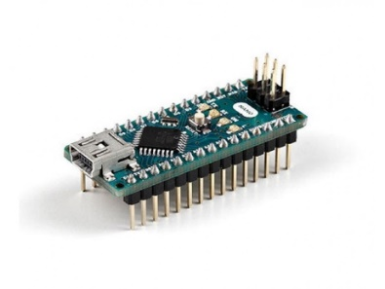**Arduino Nano:**

(Fig 3.2.1 Arduino Nano)

The **Arduino Nano** is a small, complete, and breadboard-friendly board based on the ATmega328 (Arduino Nano 3.x). It has more or less the same functionality of the Arduino Duemilanove, but in a different package. It lacks only a DC power jack, and works with a Mini-B USB cable instead of a standard one.

* 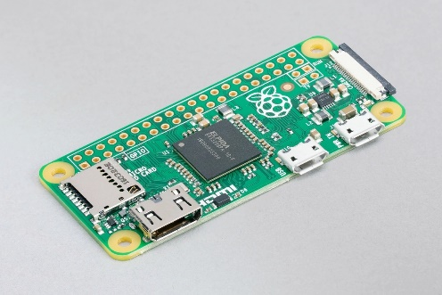**Raspberry Pi Zero Wireless:**

(Fig 3.2.2 Raspberry Pi Zero Wireless)

The **Raspberry Pi Zero** is half the size of a Model A+, with twice the utility. A tiny Raspberry Pi that’s affordable enough for any project!

* 1GHz single-core CPU
* 512MB RAM
* Mini HDMI port
* Micro USB OTG port
* Micro USB power
* HAT-compatible 40-pin header
* Composite video and reset headers
* CSI camera connector (v1.3 only)
* 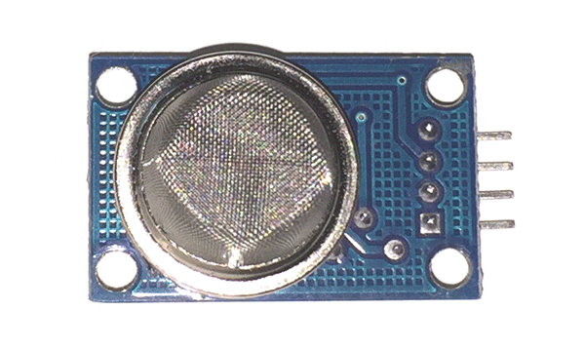**MQ-135 Gas Sensor:**

(Fig 3.2.3 MQ-135 Gas Sensor)

The **MQ-135 Gas Sensors** are used in air quality control equipment and are suitable for detecting or measuring of NH3, NOx, Alcohol, Benzene, Smoke, CO2. The MQ-135 sensor module comes with a Digital Pin which makes this sensor to operate even without a microcontroller and that comes in handy when you are only trying to detect one particular gas.

* 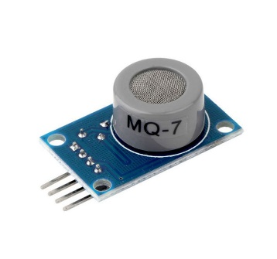**MQ-7 Gas Sensor:**

(Fig 3.2.4 MQ-7 Gas Sensor)

This **Carbon Monoxide (CO) gas sensor** detects the concentrations of CO in the air and ouputs its reading as an analog voltage. The sensor can measure concentrations of 10 to 10,000 ppm.The sensor can operate at temperatures from -10 to 50°C and consumes less than 150 mA at 5 V.

* 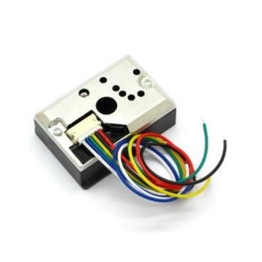 **PM2.5 Sensor:**

(Fig 3.2.5 PM2.5 Sensor)

**GP2Y1010AU0F** is an optical air quality sensor, designed to sense dust particles. An infrared emitting diode and a phototransistor are diagonally arranged into this device, to allow it to detect the reflected light of dust in air. It is especially effective in detecting very fine particles like cigarette smoke, and is commonly used in air purifier systems.

The sensor has a very low current consumption (20mA max, 11mA typical), and can be powered with up to 7VDC. The output of the sensor is an analog voltage proportional to the measured dust density, with a sensitivity of 0.5V/0.1mg/m3.

* 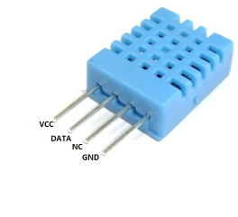**DHT11 Sensor:**

(Fig 3.2.6 DHT11 Temperature & Humidity Sensor)

The **DHT11** is a basic, ultra-low-cost digital temperature and humidity sensor. It uses a capacitive humidity sensor and a thermistor to measure the surrounding air, and spits out a digital signal on the data pin (no analog input pins needed). It’s fairly simple to use, but requires careful timing to grab data.

**3.3 Block Diagram:**

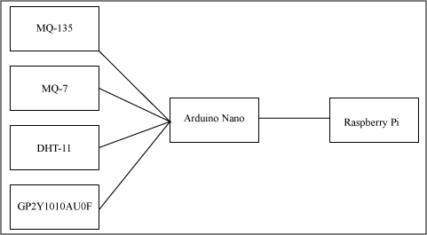

(Fig 3.3.1 Transmitter Section)

**Transmitter Section**

In the transmitter section, to monitor the parameters, we mount 4 sensors like MQ-135, MQ-7, DHT11,GP2Y1010AU0F to sense these parameters. The data from these sensors integrated with microcontroller ATMEGA328 which is mounted on Arduino Uno board operates at 5V. To allow the data to travel over an Internet we are connecting flexible wi-fi module ESP8266. It works at 3.3V.

**Receiver Section**

In the receiver section, hotspot is to be activated on user’s smartphone or pc to access web browser. An IP address is to be entered in web browser to access related web page which will show the monitoring results on user’s smartphone screen.

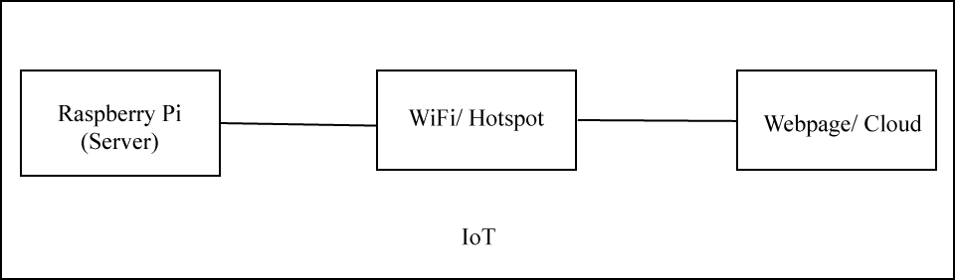

(Fig 3.3.2 Receiver Section)

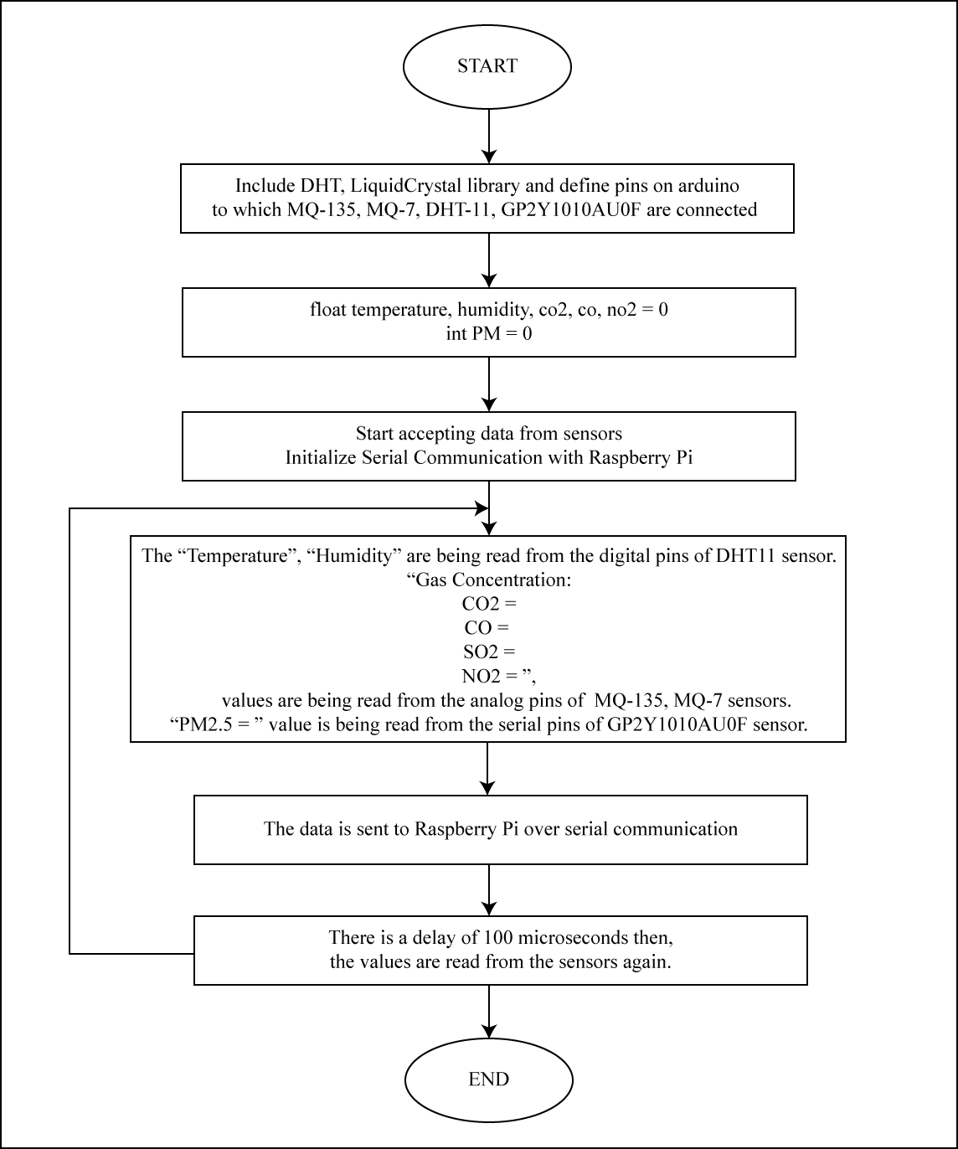

(Fig 3.3.3 Data Collection Flowchart)

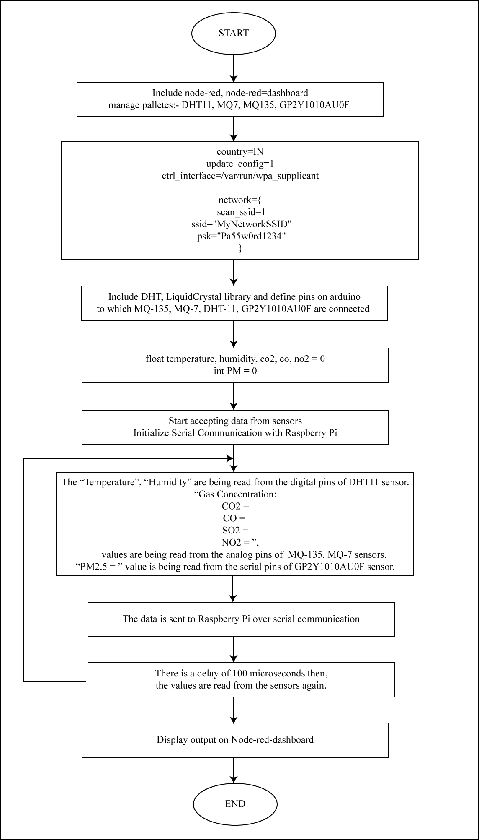

(Fig 3.3.4 System Flowchart)

**3.4 Flow of the System:**

After starting the system, we have to connect all the sensors to the microcontroller so that sensors get interfaced with microcontroller. Then process the data using microcontroller and embedded ‘c’ in Arduino uno. Send AT commands to wi-fi module 8266. Microcontroller starts processing data over an Internet. After processing, the embedded ‘c’ is uploaded in Arduino. Using hotspot, user can access internet browser on their smartphones or laptops. Web browser needs specific IP address. By putting IP address on browser, web page is displayed. Web page shows the monitoring results of the respected parameters.

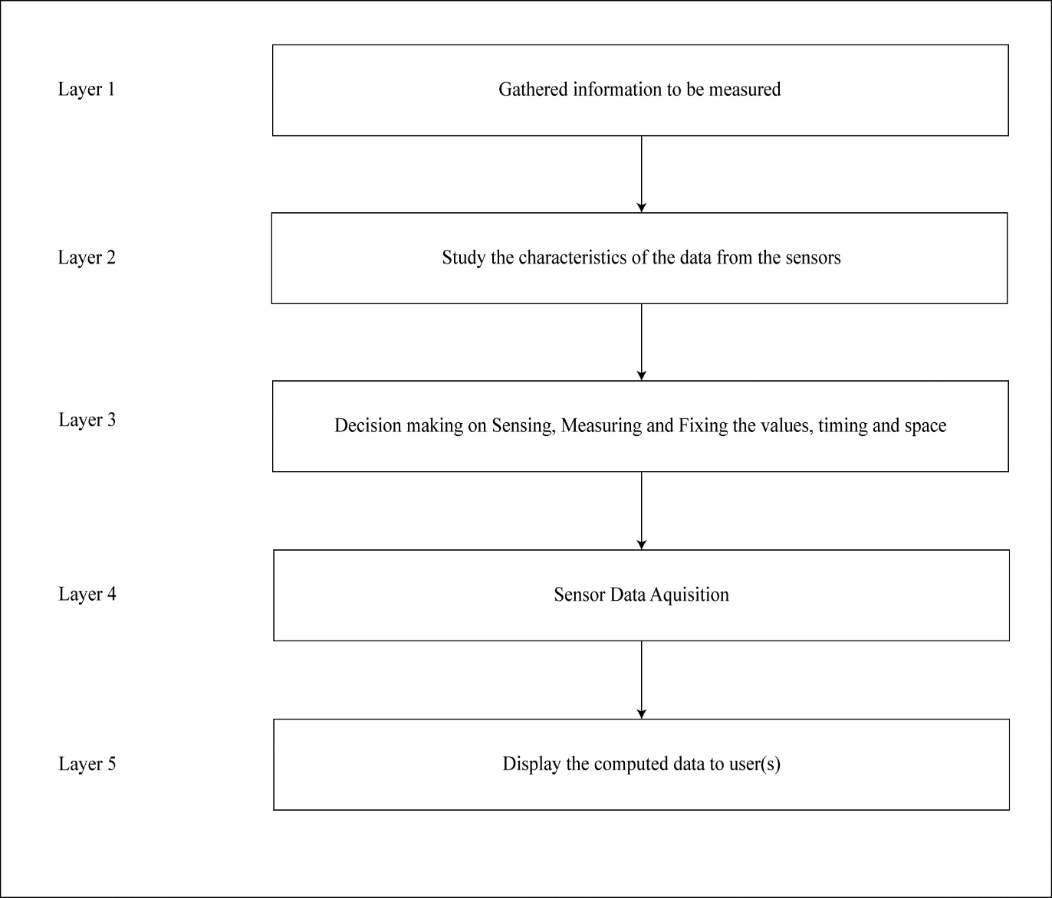

(Fig 3.4.1 System Flowchart)

## PROPOSED SYSTEM DESIGN

# The process is divided in 5 layers. The environmental parameters which are to be measured are introduced in layer 1. Study of the characteristics and features of sensor devices is in layer 2. In layer 3, there is decision making on sensing, measuring and fixing the threshold value, periodicity of sensitivity, timing, space and LED. Sensor data acquisition is done in layer 4. And layer 5 as ambient intelligence environment. The sensors can be operated by the microcontroller to retrieve the data from them and it processes the analysis with the sensor data and updates it to the Internet through Wi-Fi module connected to it. User can monitor the parameters on their smartphones as well as pc or laptop.

## 3.6 IMPLEMENTATION

## From the implementation analysis, we can able to build flourishing system that monitors the pollution causing parameters and make reliable and pollution free environment. This project is done keeping in mind the small-scale industries and hence it is affordable. Sensing systems in the environment itself will considerably raise the degree of environmental protection.

# CHAPTER – 04: METHODOLOGY

## Methodology

Our sensor-based air quality monitoring system measuring the ambient pollution is highly accurate, affordable, easy to use. Dsm501a is a pm sensor connected to digital pin 5 of arduino, dht22, bmp180 are connected to the digital pi3 and 4 of the arduino where as mq135 and mq9 are interfaced to analog pin 2 and 3 of arduino. Arduino is interfaced with raspberry pi via a usb cable. Raspberry pi is connected to internet with the help of wi-fi adapter and the adapter is connected to raspberry pi at usb port. Initially operating system has to be installed into raspberry pi by downloading image from the raspberry pi official website. The file having .zip extension has to be unzipped to retrieve .img file and write the image to the sd card. As of November 2015, version of raspbian jessie, sd card image is preinstalled with node-red and it is necessary to upgrade it.

When pi boots up using the command “sudo systemctl enable nodered.service” node-red starts running automatically. In order to use cloud services of ibm, an account is created at ibm bluemix and at the same time device is to be registered. Once the device is registered, bluemix iot platform will acknowledge the user by providing the auth token which can be used for the communication of data from device to bluemix iot platform.

The sensors are already connected to the arduino board and raspberry pi is interfaced with arduino. So, by deploying a flow containing serial in node to receive the data coming from serial port to raspberry pi, serial in node is connected to watson iot node for sending the data to the cloud.

The data can be seen on the dashboard of ibm bluemix iot platform anywhere in the world, only requirement is that device should be connected to internet.

**EXPERIMENTAL SETUP**

As shown in fig.2 the complete setup for the system consisting of sensors, Arduino, Raspberry pi has been shown.

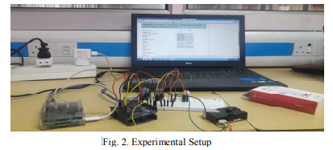

**RESULTS**

Result will display on user’s smartphone screen or pc

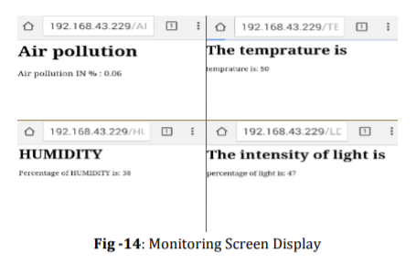

**CONCLUSION AND FUTURE WORK:**

The proposed system provides low cost, low power, compact and highly accurate system for monitoring the environment with the dedicated sensors remotely from any place in this world. A perfect tradeoff between accuracy and cost is achieved by making use of single board minicomputer Raspberry pi and appropriate sensors leading to a well-grounded system. Datasheets available on the dashboard of IBM Bluemix account will help in framing good policies against the increasing level of pollution to ensure healthful environment. Air quality monitoring system can be more advantageous if pollutants like Sulfur dioxide, nitrogen dioxide, ground level ozone etc. are also monitored. Furthermore, long-term pollution patterns can be discovered and certain relationships between the air pollutants can be found.

# CHAPTER 5: REFERENCES AND BIBLIOGRAPHY

## REFERENCES AND BIBLIOGRAPHY:

## [1] Phala, Kgoputjo Simon Elvis, Anuj Kumar, and Gerhard P. Hancke. "Air quality monitoring system based on ISO/IEC/IEEE 21451 standards." IEEE Sensors Journal 16, no. 12, pp. 5037-5045, 2016.

## [2] Zheng, Kan, Shaohang Zhao, Zhe Yang, Xiong Xiong, and Wei Xiang. "Design and implementation of LPWA-based air quality monitoring system." IEEE Access 4, pp. 3238-3245, 2016.

## [3] Marinov, Marin B., Ivan Topalov, Elitsa Gieva, and Georgi Nikolov, "Air quality monitoring in urban environments", 39th IEEE International Spring Seminar In Electronics Technology (ISSE), pp. 443-448, 2016.

## [4] Liu, X., & Baiocchi, O. (2016, October) "A comparison of the definitions for smart sensors, smart objects and Things in IoT”. 7th IEEE Conference In Information Technology, Electronics and Mobile Communication(IEMCON),pp. 1-4,2016..

## [5] Upton, Eben, and Gareth Halfacree. Raspberry Pi user guide. John Wiley & Sons, 2014.

## [6] Shete, Rohini, and Sushma Agrawal. "IoT based urban climate monitoring using Raspberry Pi", IEEE International ConferenceIn Communication and SignalProcessing (ICCSP), pp. 2008- 2012, 2016.

## [7] Jha, Mukesh, Prashanth Reddy Marpu, Chi-Kin Chau, and Peter Armstrong, "Design of sensor network for urban micro-climate monitoring", First IEEE International Conference In Smart Cities(ISC2), pp.1-4, 2015.

## [8] Nastic, Stefan, Sanjin Sehic,Duc-Hung Le,Hong-Linh Truong,and Schahram Dustdar, "Provisioning software-defined IoT cloud systems", International Conference In Future Internet of Things and Cloud (FiCloud), pp.288-295, 2014.

## [9] Nayyar, Anand, and Vikram Puri",A review of Arduino board's, Lilypad's & Arduino shields",3rd IEEE International Conference In Computing for Sustainable Global Development (INDIACom), pp.1485-1492, 2016.

## [10] [www.greenpeace.org](http://www.greenpeace.org)

## [11] Baralis, Elena, Tania Cerquitelli, Silvia Chiusano, Paolo Garza, and Mohammad Reza Kavoosifar, "Analyzing air pollution on the urbanenvironment", 39th IEEE International Convention In Information and Communication Technology, Electronics and Microelectronics (MIPRO), pp. 1464-1469, 2016.

## [12] [www.mqtt.org](http://www.mqtt.org)

## [13] Husni, E., Hertantyo, G. B., Wicaksono, D. W., Hasibuan, F. C., Rahayu, A. U., & Triawan, M. A, “Applied Internet of Things (IoT): Car monitoring system using IBM BlueMix” ,IEEE International Seminar on Intelligent Technology and Its Applications (ISITIA),pp. 417- 422,July,2016.

[14] Berl, A., Gelenbe, E., Di Girolamo, M., Giuliani, G., De Meer, H., Dang, M. Q., &

Pentikousis, K, (2010) “Energy-efficient cloud computing”The computer journal, Vol 53,

pp.1045-1051,2010.

[15] Maksimović, Mirjana, Vladimir Vujović, Nikola Davidović, Vladimir Milošević, and

Branko Perišić, "Raspberry Pi as Internet of things hardware: performances and constraints."

p.8,design issues 3,2014.

[16] Simić, Mitar, Goran M. Stojanović, Libu Manjakkal, and Krzystof Zaraska. "Multi-sensor

system for remote environmental (air and water) quality monitoring." In IEEE 24th

Telecommunications Forum (TELFOR), pp. 1-4, 2016.

[17] Chiwewe, Tapiwa M., and Jeofrey Ditsela. "Machine learning based estimation of Ozone

using spatio-temporal data from air quality monitoring stations." IEEE 14th International

ConferenceIn Industrial Informatics (INDIN),pp. 58-63, 2016.